
SEVERN ROAD CLUB
Hinton Hill Climb - Course UH90
Saturday 2nd Oct 2021 - Start time 2:30pm
Promoted for and on behalf of Cycling Time Trials under their Rules and Regulations

www.severnroadclub.co.uk
Event Secretary:  Neil Blessitt  51, Everest Road  Fishponds  Bristol BS16 2DA | Timekeepers  Bridget Boon  Ian Boon

Please note that the start sheet is found on the “start sheet” tab on the CTT website. The main hill climb event for adults follows directly after the Juvenile event. A copy forms part of this document, below.

Please pay attention to the issues below related to Covid-19.

Headquarters, Start area and Parking

The HQ for this event will be located in or next to the field being used as the event car park.

The start is next to the car park of “The Bull at Hinton” pub. This is about a minute’s ride from the event car park.

Car Parking is located in a field to the south of the road between Hinton and Pucklechurch. Look for the large triangle of grass to your left (if heading west towards Pucklechurch) as you leave Hinton village. Turn left, and take a right at the far end of the triangle. Parking is in the field, through a gate on the right. In the event of heavy rain you may be asked to park next to the field. Look out for signage. Please make sure you park as directed, leaving a decent width between you and the adjacent vehicle.

The field will be signposted with arrows. Under no circumstances can you park at The Bull pub –parking is reserved for pub customers only.

Pucklechurch and Bristol are to the left / west of the map.
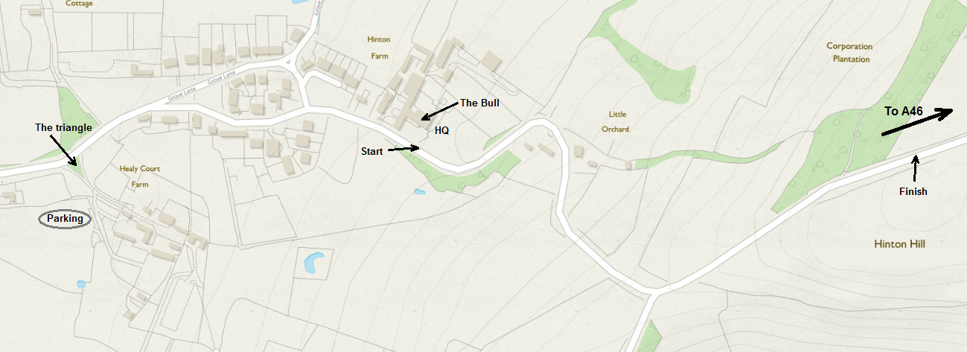

PLEASE NOTE; The HQ will be next to the car parking, NOT at The Bull

Address for “The Bull”: Hinton, Chippenham, SN14 8HG.

Toilets

Richard, the Landlord of The Bull has kindly allowed us to us the pub toilets. Please use the side entrance (Half-way along the right hand side of the pub) rather than the front one which would take you through the bars.

Food

The Bull provides food as well as drink. If you would like to eat there after the event (or before!) then Richard advises you to order in advance via the pub’s website. The menu can be found at thebullathinton.co.uk

Numbers.
Riders must sign the signing on sheet at the HQ to obtain their race number and check for any last minute information. Please don’t forget to also sign out and return your number. Please place your number into the bucket by the signing-on desk.

Course details
START: At the base of Hinton Hill next to the pub car park. Finish is at the crest of the hill just outside of the trees (approx ½ mile). See map above.

Course records:

Fastest woman: 2:20.5 Anna Fischer, Maxgear RT, 2010.
Fastest Juvenile: 2:01.7 Finlay Hawker, VC de Londres, 2020
Fastest Junior: 1.53.3 Matt Fratesi, SRC 2015
Fastest Senior: 1:47.8 Rob Gough, Artic Sram RT, 2011

SAFETY
Although the Covid situation at the time of writing is much better than in 2020 riders are asked to take care and, in particular note the following points:
- DO NOT PUT LOCAL RESIDENTS, THE EVENT ORGANISERS OR YOUR FELLOW COMPETITORS AT RISK OF COVID-19 INFECTION. If you feel unwell, or you have been in contact with someone who has Covid please stay at home. We want to be able to run this event again in the future so we don’t want to upset local residents by appearing to be irresponsible. And please remember, a negative result from a Lateral Flow Test is less reliable than a positive result. Thank you.

Other safety issues:

- You must display a red rear light. You will not be able to start without one.
- Please arrive at the start no sooner than 5 minutes before your start time.
- When racing, keep left at all times, particularly on the first bend to the right after 100m.
- Be aware of cars entering and leaving The Bull at Hinton car park
- Take care when descending the hill after you have finished. There are a number of sharp, blind bends, so please ensure that you don’t cut these corners whilst descending.
- Refrain from turning around on the race course
- CTT recommends that competitors wear a hard shell helmet that meets an internationally accepted safety standard.
- All juniors/juvenile riders MUST wear protective hard shell helmets
- We hope to have refreshments available after the event but to be sure please aim for self-sufficiency. As above, you will be welcome at The Bull.

Other things to remember:

- Please be absolutely sure that your race number will be visible to the time-keepers when you cross the finish line.
- Please note that you must not practice or warm up on the course once the event has started. Anyone found doing this will be disqualified.
- Mr Huband is very kindly allowing us to use his field as a car park. It is about 400m from the start. Please park as directed. A marshal will be on hand to help identify a place to park. Please do not churn up the ground, particularly if it is wet. Again, do not park at the pub.
- If you plan to use a turbo trainer or rollers to warm up you’ll need to bring something solid to put your trainer on.
- Please maintain reasonable social distancing.

Prizes

Prizes will be awarded to:

Placing | Prize Value
1st place overall | £20
2nd place overall | £15
3rd place overall | £10
1st female | £20
2nd female | £15
1st V40 male | £10
1st V40 female | £10
1st V50 male | £10
1st V60 male | £10
1st (fastest) female V50/60 | £10
1st Juvenile | £10
1st Junior | £10
1st (fastest) female juvenile / junior | £10

Best wishes for a safe and successful ride.

Number | Start Time | First name | Last name | Club | Gender | Category
1 | 14:31:00 | Toby | Wilson | Team Tor 2000 | KALAS | Male | Juvenile
2 | 14:32:00 | Mark | Truman | Velo Club Bristol | Male | Juvenile
3 | 14:33:00 | Freddie | Willson | Chew Valley Cycling Club | Male | Juvenile
4 | 14:34:00 | Jacob | Johnson | Bristol South Cycling Club | Male | Juvenile
5 | 14:35:00 | Harvey | Thomas | Bristol Road Club | Male | Juvenile
6 | 14:36:00 | Graeme | Rout (DNS a) | PDQ Cycle Coaching | Male | Veteran
7 | 14:37:00 | Ole | Bainbridge | Bristol Road Club | Male | Junior
8 | 14:38:00 | Harry | Chamberlain | Bynea Cycling Club | Male | Senior
9 | 14:39:00 | Andy | Collins | Chew Valley Cycling Club | Male | Veteran
10 | 14:40:00 | Caroline | Lansdown | Sodbury Cycle Sport | Female | Veteran
11 | 14:41:00 | James | Davenport | VMCC powered by Y Beic | Male | Junior
12 | 14:42:00 | Chris | Truman | Velo Club Bristol | Male | Veteran
13 | 14:43:00 | Thomas | Weir | Hitchin Nomads CC | Male | Senior
14 | 14:44:00 | Mike | Tucker | Severn Road Club | Male | Veteran
15 | 14:45:00 | Jack | Wetherbee | Surrey Hills Cycleworks | Male | Senior
16 | 14:46:00 | Wayne | Williams | PeaceFIT Racing | Male | Senior
17 | 14:47:00 | Paul | Mustow | Salisbury Road and Mountain CC | Male | Veteran
18 | 14:48:00 | Andrew | Metherell | Salt and Sham Cycle Club | Male | Veteran
19 | 14:49:00 | Vivienne | Tomlin | Avid Sport | Female | Veteran
20 | 14:50:00 | George | David | Sodbury Cycle Sport | Male | Espoir
21 | 14:51:00 | William | Scott | Bristol South Cycling Club | Male | Senior
22 | 14:52:00 | Alastair | Merrill | VC 10 | Male | Veteran
23 | 14:53:00 | Harrison | Fay | Welland Valley CC | Male | Junior
24 | 14:54:00 | Andrew | Lockwood | Chippenham & District Wheelers | Male | Senior
25 | 14:55:00 | Michael | Lee | PeaceFIT Racing | Male | Espoir
26 | 14:56:00 | Emily | Slavin | Avid Sport | Female | Senior
27 | 14:57:00 | Andrew | Kirby | 73 Degrees Bicycles, WestSide Coaching rt | Male | Senior
28 | 14:58:00 | Ed | Jarvis | Dursley Road Club | Male | Senior
29 | 14:59:00 | Paul | Derrick | Sodbury Cycle Sport | Male | Senior
30 | 15:00:00 | Charlotte | Davies | FTP (Fulfil The Potential) Racing | Female | Senior
31 | 15:01:00 | Archie | Cross | Team Lifting Gear Products/Cycles In Motion | Male | Senior
32 | 15:02:00 | Arion | Oates | PDQ Cycle Coaching | Male | Senior
33 | 15:03:00 | Robert | Borek | Bristol South Cycling Club | Male | Senior
34 | 15:04:00 | Liam | Cahill | Reflex Racing | Male | Senior
35 | 15:05:00 | Steve | Thomas | Bristol Road Club | Male | Veteran
36 | 15:06:00 | Ollie | Pennington | 1st Chard Wheelers | Male | Senior
37 | 15:07:00 | James | Scrivener | Reading CC | Male | Senior
38 | 15:08:00 | James | Meaden | PeaceFIT Racing | Male | Senior
39 | 15:09:00 | Karl | Norris | 360VRT | Male | Veteran
40 | 15:10:00 | Adrian | Lawson | Nopinz Motip Race Team | Male | Veteran
41 | 15:11:00 | Daniel | Colman | Arctic Aircon RT | Male | Senior
42 | 15:12:00 | Madeleine | Heywood | Team Watto | Female | Senior
43 | 15:13:00 | Danny | Lake | 360VRT | Male | Veteran
44 | 15:14:00 | Kate | MacTear | Bristol South Cycling Club | Female | Senior
45 | 15:15:00 | Josh | Coyne | Bpm Coaching | Male | Senior
46 | 15:16:00 | Carl | Jolly | 73 Degrees Bicycles, WestSide Coaching rt | Male | Espoir

